Atomic Mass
- The atomic number represents the number of protons in the nucleus.
- Atomic Mass Unit (AMU)
  - 1 Proton = 1 AMU
  - 1 Electron =0.0006 AMU
  - 1 Neutron = 1 AMU
- The number of protons must equal the number of electrons for the atom to be stable (meaning electrically neutral).
- An ion is an atom that is electrically charged.
  - A charge is created when electrons are transferred to or from another atom.
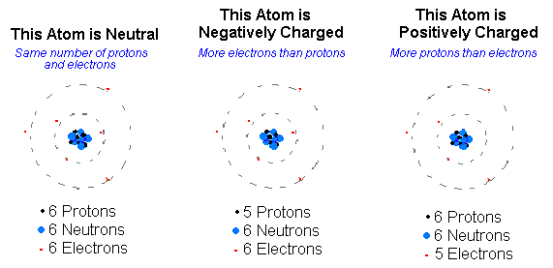
- The atomic mass is the combined mass of the protons and neutrons in the nucleus. *Also known as the “Mass Number”
- Atoms of the same element ALWAYS have the same number of protons, but the number of neutorns may vary.
- An isotope is an atom with the same number of protons and different number of neutrons than other atoms of that element.
